Activity: Team challenges

Staff Qualifications: none – can be used by group leaders unaided after onsite briefing

Staff Ratio: On – site 1 – 16 + responsible adult (i.e. teacher or youth leader).

Activity Areas: Centre grounds

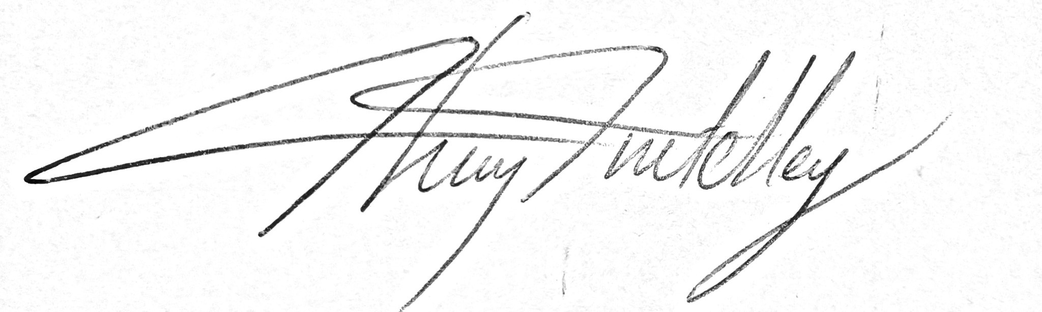
Reviewed: Jan 2024 – Chris Crutchley

Team challenges - Generic Risk Assessment
For every session the instructing staff will carry out a dynamic risk assessment from arrival and continuing throughout the activity session.
Identified Hazard | Associated Risk | Who’s at risk | Action taken to reduce/eliminate the risk
Slippery surface | Slips, trips and falls | Clients | Good briefing about terrain with good footwear to be worn
Trees | Head / body injury | Clients | Brief group to be aware of their surroundings and take their time in areas of trees
Homemade rockets | Clients standing in front of rocket launcher | Clients | Brief group not to stand in front of rocket launcher when they are being launched
Planks on swamp blocks | Falling off planks if they slip off the blocks | Clients | Brief group on correct placing of planks and ensure they are solid before use.
Wobble board | Falling off, getting foot caught under board | Clients | Brief group to move well clear of board if they fall off and make them aware of getting feet caught underneath board and therefore to keep feet away. All get on and off one end of board at the end of session
Holy tube/gutter ball run | Hit by gutters being carried | All | Make group aware of possibility of hitting people when they are lifting gutters
Spiders web | Getting dropped when being lifted through web  Back injury from lifting other clients. | Clients | Ensure good briefing to cover correct lifting procedure. Instructor to spot head of lifted client.
Night Line |  | Clients | See separate Risk Assessment “Night line”

