Activity: Pond Dipping

Staff Qualifications: none – can be used by group leaders unaided after onsite briefing

Staff Ratio: 1 – 16 + responsible adult (i.e. teacher or youth leader).

Activity Areas: In grounds

Reviewed: Jan 2024 – Chris Crutchley
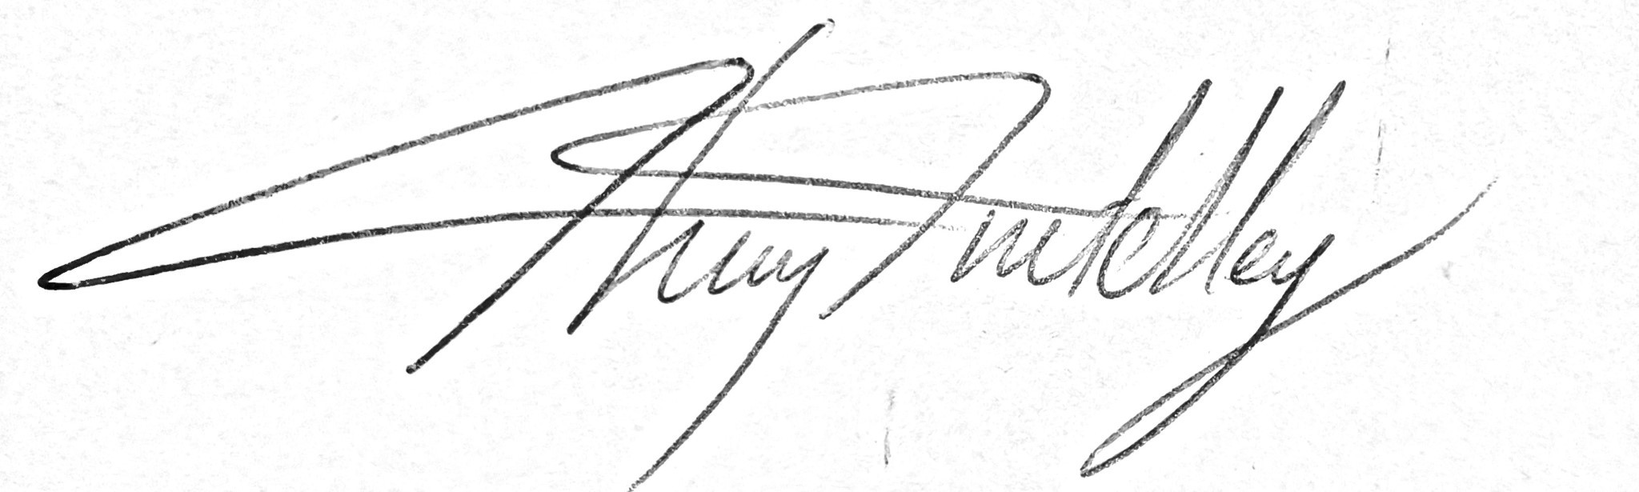
Pond dipping - Generic Risk Assessment
For every session the instructing staff will carry out a dynamic risk assessment from arrival and continuing throughout the activity session.
Identified Hazard | Associated Risk | Who’s at risk | Action taken to reduce/eliminate the risk
Falling into pond | Drowning | Clients | Instructor to brief group to be careful near edge of pond and to be sensible. Constant supervision & ongoing management.
Slipping / Tripping | Bruising | Clients | Brief group of slipperiness of surfaces and to not run.
Infection from water | Upset stomach | Clients | Remind everyone to wash hands after session.
Misuse of nets | Impact injury, bruising | All, | Brief group on appropriate behaviour when in control of a net
Covid-19 | Infection | All | Social distancing if necessary.  Equipment either cleaned after session or quarantined.

