Activity: Night Line

Staff Qualifications: none – can be used by group leaders unaided after onsite briefing

Staff Ratio: 1 – 16 + responsible adult (i.e. teacher or youth leader).

Activity Areas: Usually night line in trees at front of house, also any other night line setup.

Reviewed: Jan 2024 – Chris Crutchley

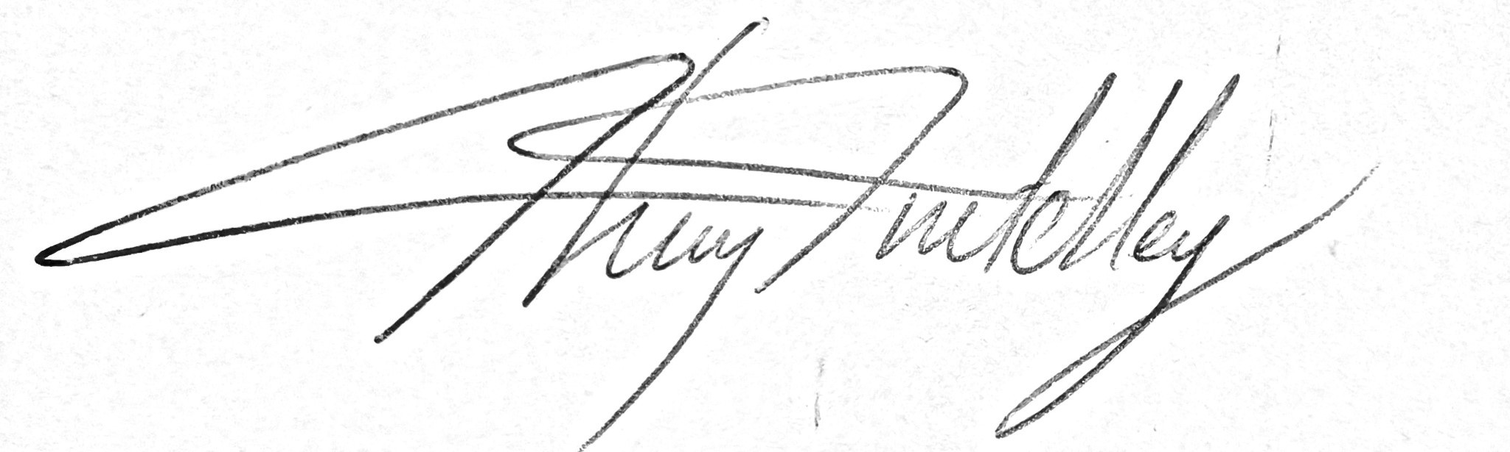

Night line - Generic Risk Assessment
For every session the instructing staff will carry out a dynamic risk assessment from arrival and continuing throughout the activity session.
Identified Hazard | Associated Risk | Who’s at risk | Action taken to reduce/eliminate the risk
Car park, cars | Impact injury | All | Brief group to be careful when in car park. Careful management. Ensure any cars or delivery vehicles are aware of the group.
Objects at head height | Bump to head, branches in face | Student | Helmets to be worn if considered necessary. Information regarding possible hazards to be relayed to anyone with a blindfold on.
Uneven ground / tree roots | Trip, fall, sprained ankle | Student | Instructor to brief group of hazards of the area. Encourage learning through communication of hazards.

