Activity: Duddon - Source to Sea

Staff Qualifications: Activity Manager approval

Staff Ratio: 1:16 plus accompanying group adults

Activity Areas: Any approved by Activity Manager

Reviewed: Jan – 2024 Chris Crutchley
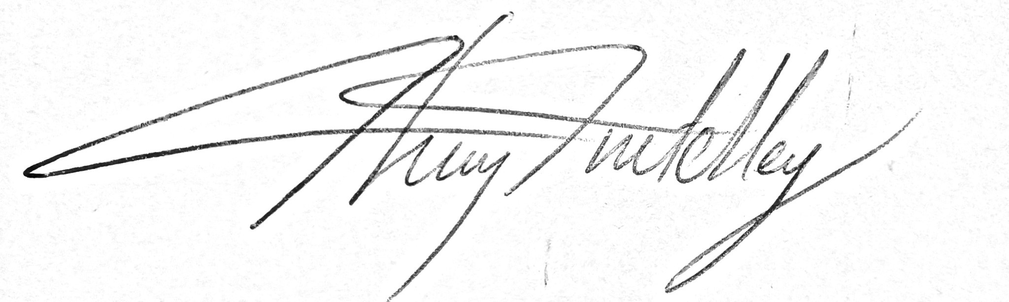

- Generic Risk Assessment
For every session the instructing staff will carry out a dynamic risk assessment from arrival and continuing throughout the activity session.
Identified Hazard | Associated Risk | Who’s at risk | Action taken to reduce/eliminate the risk
Road crossing at Wrynose Pass | Injured by traffic | Students | Group to be carefully managed whilst on or near the road.
High water | Drowning | Students | Session altered to keep group away from river in dangerous water levels
Deep water | Drowning | Students | Students to be kept away from deep water sections of the river. Staff to be observing students at all times if they are wading in the river.
Cold water | Hypothermia | Students | Students kept out of water if the weather is cold.  Spare clothes and warm drinks to be on hand if necessary
Soft mud/quicksand at the estuary | Getting stuck and drowning | Students | Group well monitored during the estuary exploration to ensure no one is straying into dangerous areas.
Incoming tide cutting group off at the estuary | Drowning | All | Instructor to be aware of state of tide and an escape route back to high ground.
Rail crossing at Foxfield | Injury/death by train | All | Group only to cross the railway line with an instructor or group adult and after acknowledgement by the crossing attendant.

