**Activity: River Irt - Source to Sea study day**

**Staff Qualifications:** Activity Manager approval

**Staff Ratio:** 1:16 plus accompanying group adults

**Activity Areas:** Any approved by Activity Manager

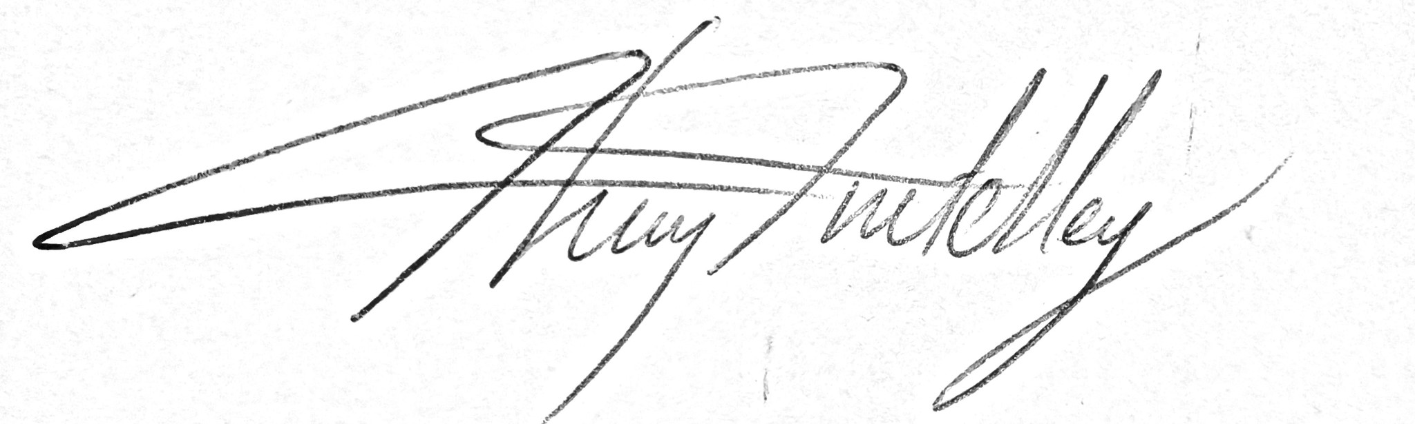**Reviewed:** Jan – 2024 Chris Crutchley

| - Generic Risk Assessment | | | |
| --- | --- | --- | --- |
| **For every session the instructing staff will carry out a dynamic risk assessment from arrival and continuing throughout the activity session.** | | | |
| **Identified Hazard** | **Associated Risk** | **Who’s at risk** | **Action taken to reduce/eliminate the risk** |
| Road crossings – Wastwater YHA and Santon Bridge, possibly others | Injured by traffic | Students | Group to be carefully managed whilst on or near the road. |
| High water | Drowning | Students | Session altered to keep group away from river in dangerous water levels  Throw line available if necessary. |
| Deep water | Drowning | Students | Students to be kept away from deep water sections of the river. Staff to be observing students at all times if they are wading in the river. |
| Cold water | Hypothermia | Students | Students kept out of water if the weather is cold.  Spare clothes and warm drinks to be on hand if necessary |
| Soft mud/quicksand at the estuary | Getting stuck and drowning | Students | Group well monitored during the estuary exploration to ensure no one is straying into dangerous areas. |
| Incoming tide cutting group off at the estuary | Drowning | All | Instructor to be aware of state of tide and an escape route back to high ground. |