Activity: Crate stacking

Staff Qualifications: Climbing wall instructor, Rock Climbing Instructor or Higher
Or In House Assessment by Technical Advisor

Staff Ratio: 1 – 16 + responsible adult (i.e. teacher or youth leader).

Activity Areas: Crate stacking area on site

Reviewed: Jan 2024 – Chris Crutchley
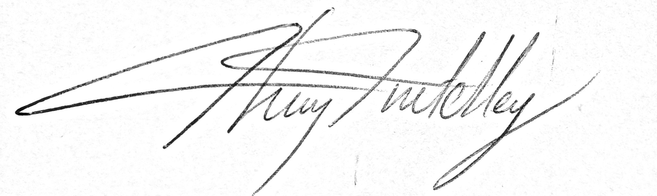
Crate stacking - Generic Risk Assessment
For every session the instructing staff will carry out a dynamic risk assessment from arrival and continuing throughout the activity session.
Identified Hazard | Associated Risk | Who’s at risk | Action taken to reduce/eliminate the risk
Falling | Impact injury | Climber | Ensure belay is kept tight especially if climber is less than 2m off the ground.  Appropriately fitted PPE to be worn.  Low stretch rope to be used.  Instructor to be holding dead rope all times the climber is off the ground.  Climber to be tied in rather than clipped in.  Climber encouraged not to pull up on the rope.
Inverting during a fall | Impact injury | Climber | Sit harness and chest harness or full body harness to be worn
Falling crate | Impact injury | Students and staff on ground | Helmets to be worn by everyone until the activity has finished.  Tower must not be manually supported to avoid people being static in the impact zone.  Group briefed to be aware of crates falling at any time.  Pole to be used to pass crates up instead of throwing.  Tower orientated to fall away from belayers.
Equipment failure | Impact injury | Climber | Regular documented checks, appropriate use of equipment & visual checks whilst on session. Anchors to be checked regularly and replaced as necessary.
Fingers caught between crates | Crush injury | Builders | Ensure the group is aware of the possibility of and avoids fingers getting caught between crates as they are stacked.
High winds | Increased stress on equipment.  Falling branches | All | Activity not to be used in strong winds as recommended by the constructors
Safe working load of activity | Damage/failure of equipment and tree | Climbers | As recommended by the constructors, normally no more than 120kg (18 ½ stone) per person. 320kg in total.

Crate stacking – wheel chair users - specific Risk Assessment
For every session the instructing staff will carry out a dynamic risk assessment from arrival and continuing throughout the activity session.
Identified Hazard | Associated Risk | Who’s at risk | Action taken to reduce/eliminate the risk
Client unable to move away from falling crates/tower | Impact injury | Client | If the client is fully immobile, their feet must be level with the top of the tower throughout so that they cannot be hit by falling crates/tower.  Other wheelchair users on the ground must be positioned well away from any area that may be affected by falling crates.
Discomfort and possible injury due to harnessing | Injury | Client | Harnessing to be done in a carefully considered fashion and in constant communication with the user or their carer if the user is non-communicative. Hoisting must be paused as soon as the full weight of the client has come onto the harness in order to check the comfort and wellbeing of the client.
Emotional wellbeing | Emotional distress | Client | The emotional wellbeing of the client must be continually checked, particularly if the client is unable to communicate verbally.
Misuse of equipment | Equipment failure and impact injury | Client | Only staff signed off by the Activity Manager may use the hoist system on the crate stack activity.

Procedure for hoisting wheelchair users
- Hoisting on the client’s rope is done using a jumar with a pulley attached and a Rig on the anchor point to form a 3-1 mechanical advantage. Only to be done with the Activity Manager’s authorisation.
- Attaching into the kite harness and sit harness: Important to remember to have the sling from the sit harness slack so that the clients weight is taken by the kite harness and not the sit harness.

