Activity: Mini bus use

Staff Qualifications: D1 or B1 plus over 25, more than 2 years driving and operating in a voluntary role

Staff Ratio: 1 – 16

Reviewed: Jan 2024 – Chris Crutchley
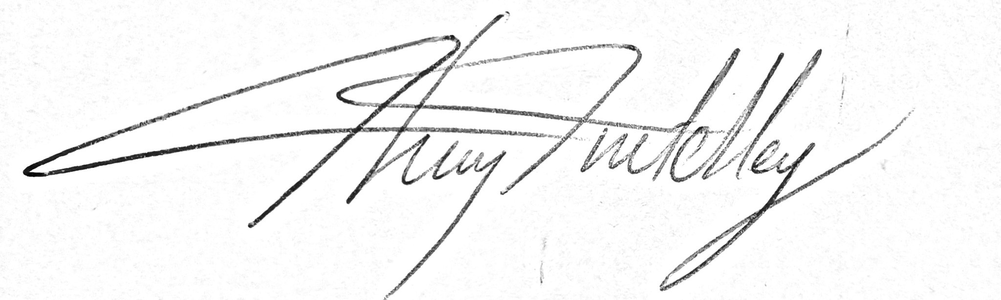
Mini bus use - Generic Risk Assessment
Identified Hazard | Associated Risk | Who’s at risk | Action taken to reduce/eliminate the risk
Road Accident | Injury/death | All | Driver to hold appropriate qualification for driving a minibus.  Driving licence check to be carried out before driver starts driving for the first time and on an annual basis thereafter.  Driver to drive according to the Highway Code and appropriate to the road conditions.  Minibus to be routinely checked for mechanical integrity.  Minibus to be road legal with regards to up to date MOT.  Driver must ensure all passengers have a seat belt securely fastened before pulling away.
Removable seats | Incorrectly attached, becoming loose | Passenger | Seats only to be re-installed by a driver approved by the Activity Manager.
Distracting behaviour by passengers | Driver distracted leading to accident | All | Responsible adult to travel in the back of the bus if deemed necessary by the driver
Safeguarding issues | False accusations | Staff | If vulnerable Under 18s considered at risk of making accusations against the driver are being driven, a second adult must be present in the bus.
Wheelchair attachment | Incorrect attachment, injury | Wheelchair user and other passengers | Only staff approved by the Activity Manager are allowed to strap wheelchair users into the bus.
Wheelchair ramps | Chair and user falling off ramps | Chair user | Chair user must be spotted by a member of staff as they ascend and descend the chair ramp.
Covid -19 | Infection | All | The minibus is cleaned using a fogger and anti-viral disinfectant after use.  During use, any occupants not within a bubble must be sitting 1m apart.  All occupants regardless of bubbling must be wearing a face mask and the windows will be kept open to ensure adequate ventilation.

