Activity: Tree Climbing

Staff Qualifications: Climbing wall instructor, Rock Climbing Instructor or higher or In House Assessment by Technical Advisor

Staff Ratio: 1 – 16 + responsible adult (i.e. teacher or youth leader).

Activity Areas: Climbing Tree on site

Reviewed: Jan 2024 – Chris Crutchley
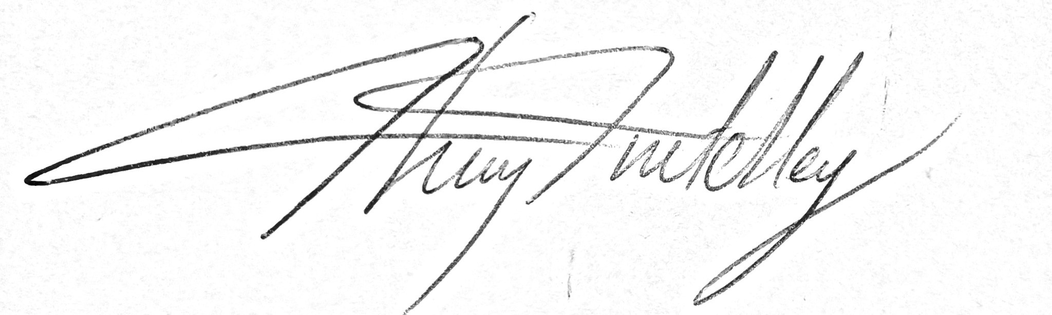
Tree climb - Generic Risk Assessment
For every session the instructing staff will carry out a dynamic risk assessment from arrival and continuing throughout the activity session.
Identified Hazard | Associated Risk | Who’s at risk | Action taken to reduce/eliminate the risk
Falling | Impact injury | Climber | Ensure belay is kept tight especially if climber is under 2m off the ground. Appropriately fitted PPE to be worn. Instructor to be holding dead rope or be in reach of dead rope at all times the climber is off the ground
Falling object | Impact injury to head | All | Helmets to be worn by anyone climbing or directly under the climbing tree
Cold muscle injury | Soft tissue injury | Climber | Ensure appropriate warm up has been done before climbing commences if necessary particularly for older climbers
Equipment failure | Impact injury | Climber | Regular documented checks, appropriate use of equipment & visual checks whilst on session. Tree anchors to be checked regularly and replaced as necessary
Letting go & falling | Impact injury | Climber | Tight safety rope – Instructor to be holding dead rope or be in reach of dead rope at all times the climber is off the ground. Belaying group to be appropriately managed.
Rings & jewellery | Jewellery catching | Climber | All rings and jewellery must be removed or taped before climbing
Getting stuck | Emotional wellbeing | Climber | A back rope will be used to help people off branches, also useful in guiding descent.  Climbers not to be forced beyond where they want to go
Unintentional release of back rope | Impact injury | Climber | Careful management of back rope needed on descent, preferably with the supervision of visiting leader.
Slippery platform | Slips, falls | All | Instructor to make group aware of slippery platform if it is wet.
Getting tangled in unused tracer lines | Getting stuck | Climber | Instructor to be aware of possibility of climber getting tangled in unused tracer lines and to encourage movement away from them.
Belayer’s clothing stuck in Petzl Rig | Ripped clothes | Belayer | Belayer to stand clear of the Petzl Rig and karabiner. If clothing does become stuck, climber must get his weight onto the tree to enable tension to be taken out of Petzl Rig

Hoist system for clients with disabilities – Specific Risk Assessment
For every session the instructing staff will carry out a dynamic risk assessment from arrival and continuing throughout the activity session.
Identified Hazard | Associated Risk | Who’s at risk | Action taken to reduce/eliminate the risk
Harness | Harness failure and falling | Climber | Climber to wear an in date sit harness as the main safety PPE as well as the Troll Kite harness
Swinging into tree | Impact injury | Climber | Back rope to be very carefully managed. The group on the back rope must be carefully briefed by the instructor and must be under the supervision of an adult or instructor
Hitting branches | Impact injury | Climber | Use of back rope and instructor at the top of the tree to guide the climber away from striking limbs on branches
Belay for instructor at top of tree | Belay failure | Instructor climber | Belay for the instructor at the top of the tree must be on a direct belay to the large fir tree and an in service climbing rope must be used.
Discomfort of disabled climber | Bruising | Climber | Climber to be consulted as to how comfortable they feel in the harness once they have been lifted out of their chair and harness and padding re-adjusted if necessary before continuing with the hoist.
Misunderstanding of course of events | Injury from falling, bashing into tree | Climber | The whole event from when the climber leaves their seat to when they arrive back in their seat is to be carefully controlled by a lead instructor signed off to run the hoist system by the Activity Manager.

