Activity: Archery

Staff qualifications: Archery GB Leader or in House assessment

Staff ratio: 1 – 16 + responsible adult (i.e. teacher or youth
leader).

Activity areas: Archery field on site or other suitable location approved by the Activities Manager

Student equipment needed: Appropriate footwear and clothing

Instructor equipment: Selection of bows appropriate to the groups needs
Arrows and quivers
Target, target face and pins
Arm guards (bracers)
Spare strings
First Aid Kit
Appropriate shooting and waiting lines

Reviewed: Jan 2024 – Chris Crutchley
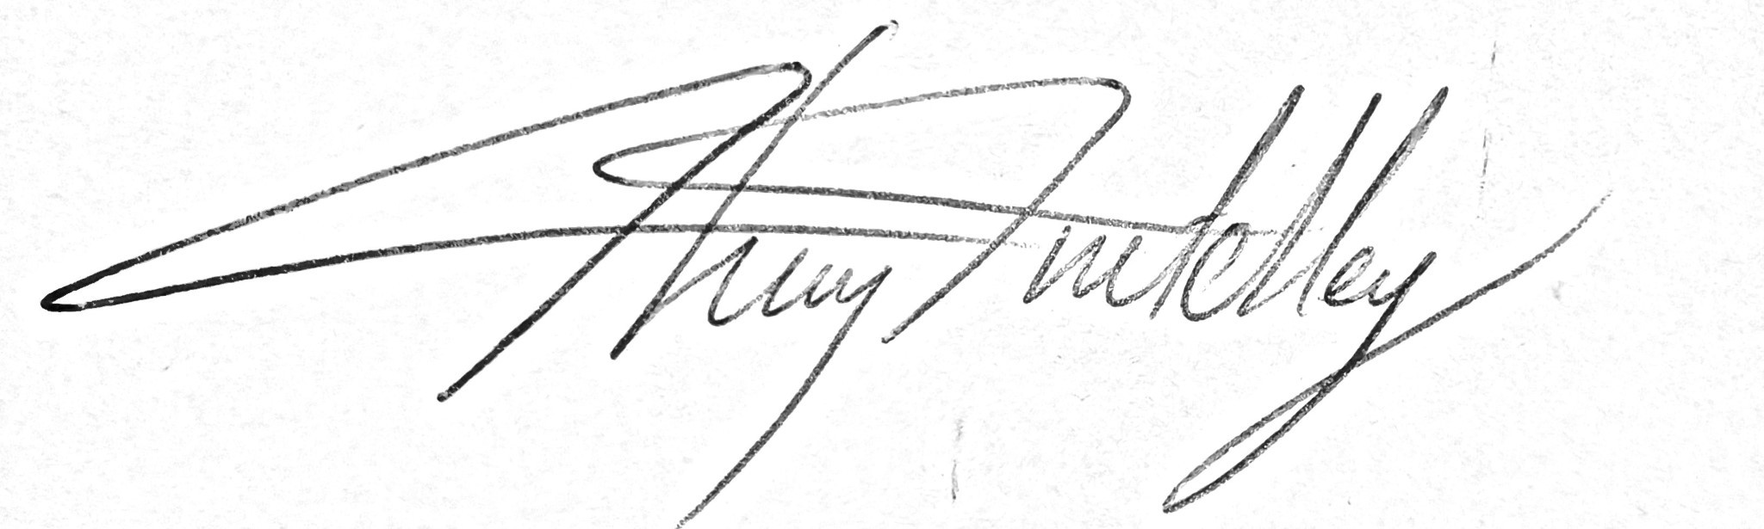

The Session

All participants must be made aware of the potential dangers of archery. The following strict rules must be adhered to throughout the session.
- Equipment is only used in the shooting area and with the instructor’s consent. A bow and arrow must only be drawn on the shooting line with the instructor’s permission. The arrow must always be pointed at the target.
- No running on the archery field.
- Anyone seeing an animal or person crossing, or approaching the shooting area must call ‘STOP’. Immediately, everyone must lower their bow and disarm it, replacing the arrow in the quiver. Shooting can continue when the instructor says so.
- No one to enter the shooting area without the instructor’s permission. When not shooting, group members and spectators should be seated at the back of the shelter or similar designated safe area.
- It maybe necessary for archers to be nearer the target because of the special needs of our visiting groups. Only take archers closer to the target if they don’t have the physical strength to hit the target from the full range. It must be noted the risk of being hit by an arrow increases significantly the closer you go, due to arrows rebounding so great caution and supervision needed. The large recurve bows are NOT to be used any closer to the target than the edge of the shelter due to arrows rebounding.
- On completion of shooting, an archer should put down the bow and move back from the shooting line. No one crosses the line until everyone has finished and the instructor gives the signal.
- Approach the target slowly from the side, Iooking for arrows that have fallen short. Never approach the target directly, because of the risk of walking onto an arrow sticking out from the target. Never stand behind someone removing arrows from the target or ground and check behind you before removing your own.
- Search for arrows behind the target. Always carry collected arrows point down. If it is necessary to cross the fence, this must only be done by instructors. Before leaving the group, the instructor must be satisfied that no archery will take place. Take the arrows with them if necessary.
- Ensure that livestock are not grazing closely in the field behind the range during a session.
- At no time should bows and arrows be left out unattended. The bows and arrows will not be stored together.
- Arm guards are recommended to be worn when shooting.
- Warning signs to be placed at entrance to range on both sides with appropriate physical barrier.

Archery– Generic Risk Assessment
Identified Hazards | Associated Risk | Who might be harmed? | Action taken to reduce/eliminate the hazard specific
Getting shot | Death or serious wounding | All | All people are to remain behind shooting line whilst shooting is taking place. Strict control of where arrow is pointed – on going management  Warning signs and barriers to be put up at entrance of range.  Good Instructor and group awareness of those approaching range.  Arrows and bows not to be left unattended or stored together.
Arrows bouncing back from target | Serious wounding | All | Large re-curve bows only to be used from the front of the shelter and no further forward due to their increased power, raising the likelihood of an arrow bouncing back.
Tripping over arrow | Bruising or laceration | All | Approach the target from the side  No running on the range
Taking arrows from boss | Stabbed by rear of arrow | All | Good briefing so that archers don’t stand directly behind someone removing an arrow.  Archers should check behind them before removing arrow
String catching body parts | Bruising | Archer | Correct body position to be demonstrated  Arm guards used if necessary  Pad on chest used if necessary
Covid-19 | Infection | All | Bows and arrows will be cleaned with anti-viral disinfectant after use.  Students will be instructed from a safe distance. If they need physical help, this can be carried out by the visiting bubbled member of staff.

Archery on ranges away from Centre – Generic Risk Assessment
To be used in conjunction with Archery Generic Risk Assessment
Identified Hazards | Associated Risk | Who might be harmed? | Action taken to reduce/eliminate the hazard specific
Getting shot | Death/injury | Members of public | Any range to be set up according to Archery GB guidelines. Range to be cordoned off with appropriate signage to make public aware of ongoing archery
Heavy target stands | Manual handling injury | Staff | Correct manual handling techniques to be used and enough manpower provided.
Arrows lost | Injury from tripping over lost arrows | Members of public | Net to be erected if grass is long enough to conceal arrows that haven’t hit the target

Kepplewray archery range – Site Specific Risk Assessment
To be used in conjunction with Archery Generic Risk Assessment
Identified Hazards | Associated Risk | Who might be harmed? | Action taken to reduce/eliminate the hazard specific
Path down to archery range | Slipping | All | Instructor to be brief group on the state of the path  Wheelchair users to be assisted down with rope tied to their chair.
Livestock behind range | Livestock injury | Livestock | Make sure no livestock are present behind the range.
Slippery surface on range | Falling | All | Excessive use of archery range can cause mud patches, these can become slippery. Guests are to be made aware of the hazard, avoid slippery patches where possible.

