Activity: Bushcraft

Staff Qualifications: Lead – Appropriate bushcraft qualification or in house training

Staff Ratio: 1:16 plus visiting leader (1:6 using edged tools)

Activity Areas: Any area agreed with the Activity Manager

Reviewed: Jan 2024– Chris Crutchley
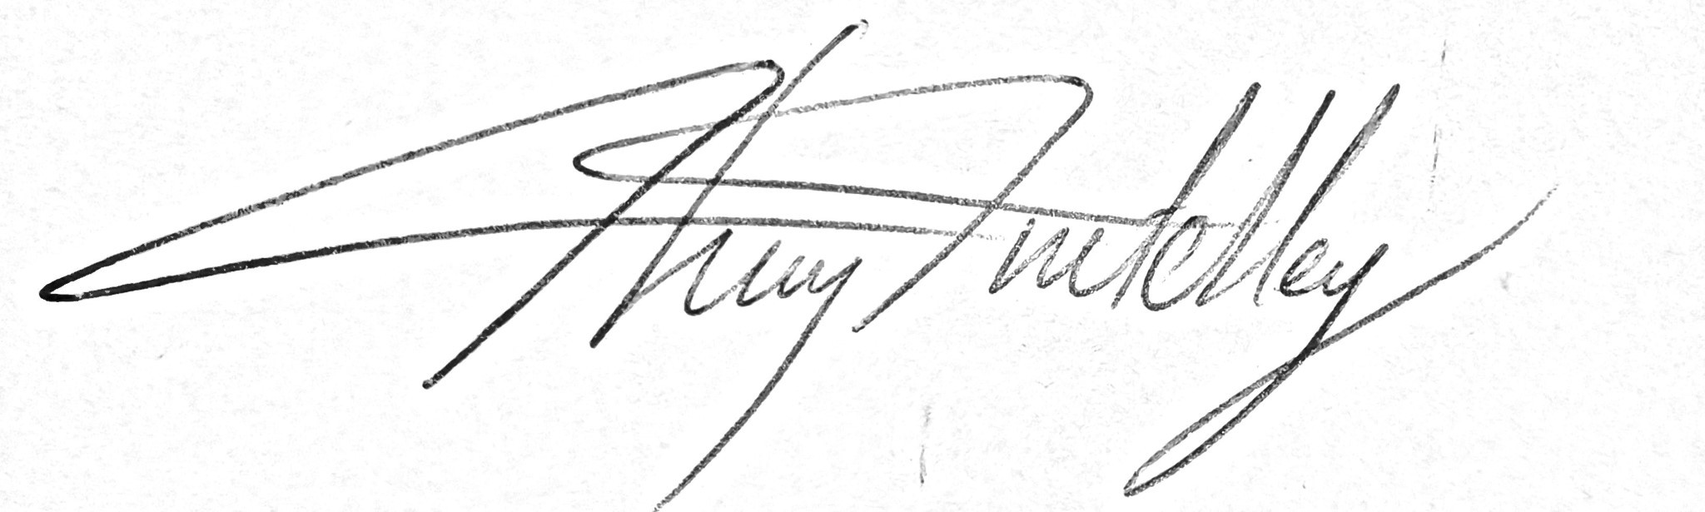

Bushcraft – Generic Risk Assessment
Identified Hazards | Associated Risk | Who might be harmed? | Action taken to reduce/eliminate the hazard specific
Fire | Burn injuries | All | Careful management of fire and appropriate usage for type of group. Needs constant management.  Burns kit to be carried.  Water available to put fire out or to treat burns.
Hot objects | Burn injuries | All | Gloves made available for handling hot objects.  Closely supervise any cooking and particularly any pots of boiling water.  Make sure group are aware of the heat of a melted marshmallow – count slowly to 10 between taking it out of the fire and eating it.
Cooking | Poisoning from poorly cooked food | All | If raw meat is to be cooked, it must be cut open to check it is cooked right through.  Hand gel available
Edged tools | Cut and stab wounds | All – | Only to be used with a suitable group.  Ratio is 1:6 people using tools  Correct procedure to be demonstrated and adhered to – knives only used when sat or kneeling.  No walking around with tools.  Correct spacing between participants – two arm spans between each person. Tools sheathed when not in use and kept in a secure container, counted out and counted back in again.
Kelly Kettle | Scalds | All | Not to be placed on fire with the stopper in. Correct demonstration of removal from fire and how to pour to be done. Removed from fire using handle at 90 degrees from kettle and poured by holding handle and pulling base up with stopper chain.  Gloves supplied.
Wild food | Poisoning | All | Only plants to be consumed that have a 100% positive identification.  Not to be collected from a contaminated source.  Only ingest a very small amount on the first go.

Bushcraft – Generic Risk Assessment
Identified Hazards | Associated Risk | Who might be harmed? | Action taken to reduce/eliminate the hazard specific
Shelter building | Crush | All | Staff to ensure that main supporting poles are strong enough to support the structure.  Long poles/branches must be carried between two people or dragged by one person.  Make participants aware of any guy lines from tarpaulins that are trip hazards.
Covid-19 | Infection | All | Any tools will be disinfected after use with anti-viral disinfectant or quarantined.  Assistance will be done verbally to maintain social distancing  If physical assistance is needed with a task, the bubbled visiting member of staff can assist.

Additional considerations for wheelchair users:
- Ensure the site is accessible for the whole group
- Consider whether the wheelchair user is able and keen to come out of their chair onto the ground and if so, what additional seating/padding will be required.
- Consider the positioning of wheelchair users with regards to smoke direction particularly if they are unable to manoeuvre themselves.

