Activity: Camping

Staff Qualifications: Lead – In House training & assessment, Summer Mountain Leader or Camp Leader

Staff Ratio: 1:16 plus visiting leader

Activity Areas: Any area agreed with Activity Manager

Reviewed: Jan – 2024 Chris Crutchley
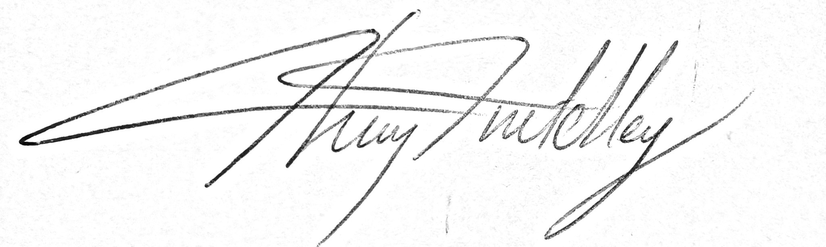
Camping – Generic Risk Assessment
Identified Hazards | Associated Risk | Who might be harmed? | Action taken to reduce/eliminate the hazard specific
Guys, pegs, uneven ground | Tripping causing injury | All | Group awareness, careful placing of guys and pegs, place cooking stoves away from trip hazards and tents
Stove | Burn Injuries | All | Groups well briefed on use of stove. Trangia stoves to be used with methylated spirit or gel. Careful management appropriate to groups needs. Only staff members are to re-fuel the stoves. Stoves to be placed in a circle or against a wall to avoid people stepping over them.
Boiling water | Scalds | All | Pouring of water from pots to be conducted in a safe controlled manner after good briefing and demonstration.  Burns kit and cold water available to treat scalds.
Hygiene & health | Ill health caused by poor hygiene and /or poorly cooked food. | All | Use sites with fresh water facilities and toilets where possible. Or boil water for minimum of 5 minutes before use.  Prepare food which does not carry a high risk of food poisoning.  Teach and observe cooking skills.  Provide alcohol wipes/gel for cleaning hands.
Extreme weather | Hypothermia & exposure | All | Careful management of where to pitch camp.  Spare clothes for group members.  Appropriate exit strategy if necessary.
Fire | All – burn injuries |  | Careful management of fire and appropriate usage for type of group. Needs constant management.  Burns kit to be carried.  Appropriate distance away from tents depending on weather conditions
Smoking | Setting fire to tents | All | No smoking to be done in or near tents. Group to be briefed and monitored appropriate to their needs.

Sunnybank Camping – Site Specific Risk Assessment
To be used in conjunction with Camping Generic Risk Assessment
Identified Hazards | Associated Risk | Who might be harmed? | Action taken to reduce/eliminate the hazard specific
Lake | Drowning | All | Swimming not permitted unless buoyancy aids are available or a member of staff with a Life Guard qualification.  Water can be entered but only knee deep and member of staff must be in constant attendance on the shore.
Livestock | Livestock escaping  Contamination from faeces | Livestock,  campers | Ensure gate is kept closed at entrance to the field.  Hand gel must be available for cleaning hands prior to cooking
Sunnybank House | Disturbance to residents | Residents | Campers must be kept away from the house with noise kept to a minimum after 11pm  Campers must stay in the camping field as much as possible.

Hazel Head Farm (Charlie’s) Camping – Site Specific Risk Assessment
To be used in conjunction with Camping Generic Risk Assessment
Identified Hazards | Associated Risk | Who might be harmed? | Action taken to reduce/eliminate the hazard specific
River | Drowning | All | Campers must be supervised by member of staff if they want to paddle.  Only to be done if river is at a suitable level as judged by the instructor.  Swimming must not occur unless a member of staff has a Life Guard qualification.
Livestock | Livestock escaping | Livestock | Ensure gates are kept closed.  Groups must be briefed on the importance of doing this.  Groups must also adhere to any areas that Charlie declares to be out of bounds due to presence of livestock.
Barn | Burning | All | Cooking on stoves not to be conducted in barn due to highly flammable nature of the building.  Briefing on the urn and use of the urn to be given to the group.
Meadow grasses and flowers | Hayfever | Hayfever sufferers | If possible, Activity Manager should arrange for guests suffering from Hayfever to camp at an alternative campsite.  At a minimum they should be briefed the campsite is in a hayfield and to take appropriate medication.
No mobile signal | Out of contact | All | The landline at the farmhouse can be used in an emergency - 01229 716531

Bev’s Camping – Site Specific Risk Assessment
To be used in conjunction with Camping Generic Risk Assessment
Identified Hazards | Associated Risk | Who might be harmed? | Action taken to reduce/eliminate the hazard specific
River | Drowning | All | Campers must be supervised by member of staff if they want to paddle.  Only to be done if river is at a suitable level as judged by the instructor.  Swimming must not occur unless a member of staff has a Life Guard qualification.
Stepping stones over river | Drowning | All | Stepping stones only to be used if river is at a reasonable level
Livestock | Livestock escaping | Livestock | Ensure gates are kept closed.  Groups must be briefed on the importance of doing this.  Groups must also adhere to any areas that the owner declares to be out of bounds due to presence of livestock.
No mobile signal | Out of contact | All | The landline in Bev’s hut can be used in an emergency.

